Special permissions give advanced privileges over the standard set of permissions. There is a special permission for each access level.

For **User**: SUID

For **Group**: GUID

For **Other**: Sticky Bit

To define these permissions numerically, below bits are used:

User: 4

Group: 2

Other: 1

None: 0

-----------------------------------------------------------

**SUID: Set User ID**

A file with **SUID** always executes as the user who owns the file, regardless of the user passing the command.

Syntax:

chmod u+s <filename>

or

chmod 47xx <filename> where x= any permission (7/4/2/1 etc.)

**Assignment 1: [Create a use case using absolute/numeric method]**

Step 1: Created a file from Devops user

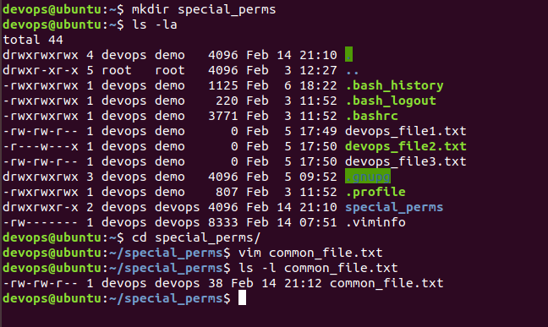

Step 2: Set UID on that file for ‘User’ Entity and change the user to demo



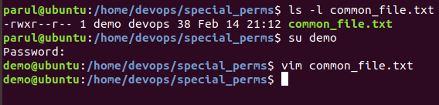

Step 3: Demo user is now able to edit/write the common_file.txt

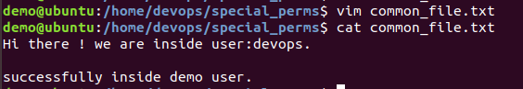

**GUID: Set Group ID**

This special permission has a couple of functions:

* If set on a file, it allows the file to be executed as the **group** that owns the file (similar to SUID)
* If set on a directory, any files created in the directory will have their **group** ownership set to that of the directory owner
* This permission set is noted by a lowercase **s** where the **x** would normally indicate **execute** privileges for the **group.** If the owning group does not have execute permissions, then an uppercase **S** is used.

Syntax:

chmod g+s <filename>

or

chmod 2x7x <filename> where x= any permission (7/4/2/1 etc.)

Step 1: Created a Directory and 2 files under this dir. from ‘Devops’ user

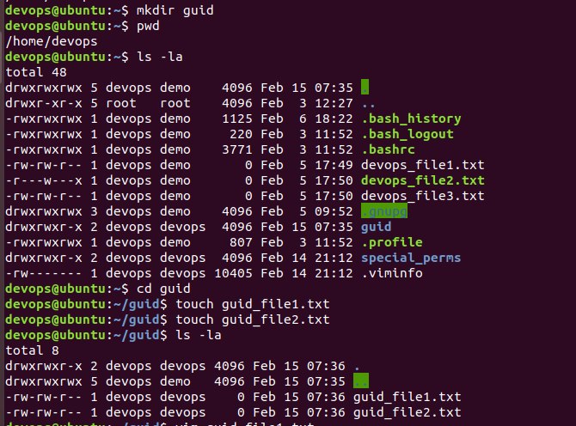

Step 2: Set Group UID on guid directory

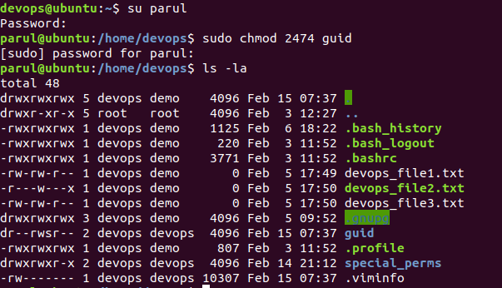

Change group to demo

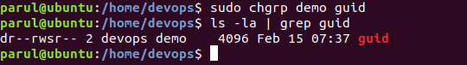

Now, we try to edit the underlying files of guid from user: demo

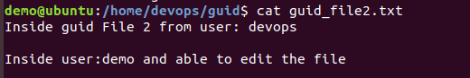

**Sticky Bit:**

This permission does not affect individual files. However, at the directory level, it restricts file deletion. Only the **owner** (and **root**) of a file can remove the file within that directory.

Syntax:

chmod o+t <filename>

or

chmod 1xx7 <filename> where x= any permission (7/4/2/1 etc.)

Step1: Created a directory and a file inside devops.

POV: Try to remove file from user Parul (a sudo user)

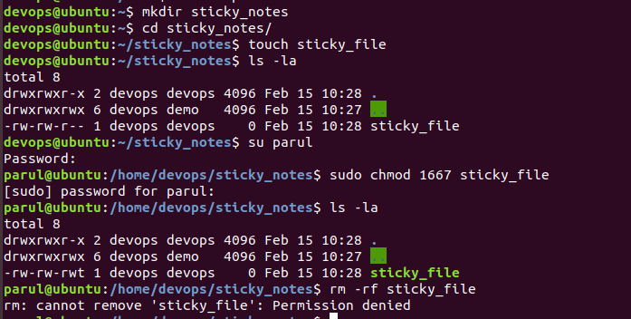

Now switch to user: devops and try to remove the file.

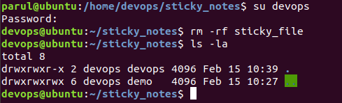

File gets deleted successfully.